# How to Create a User-Friendly Website

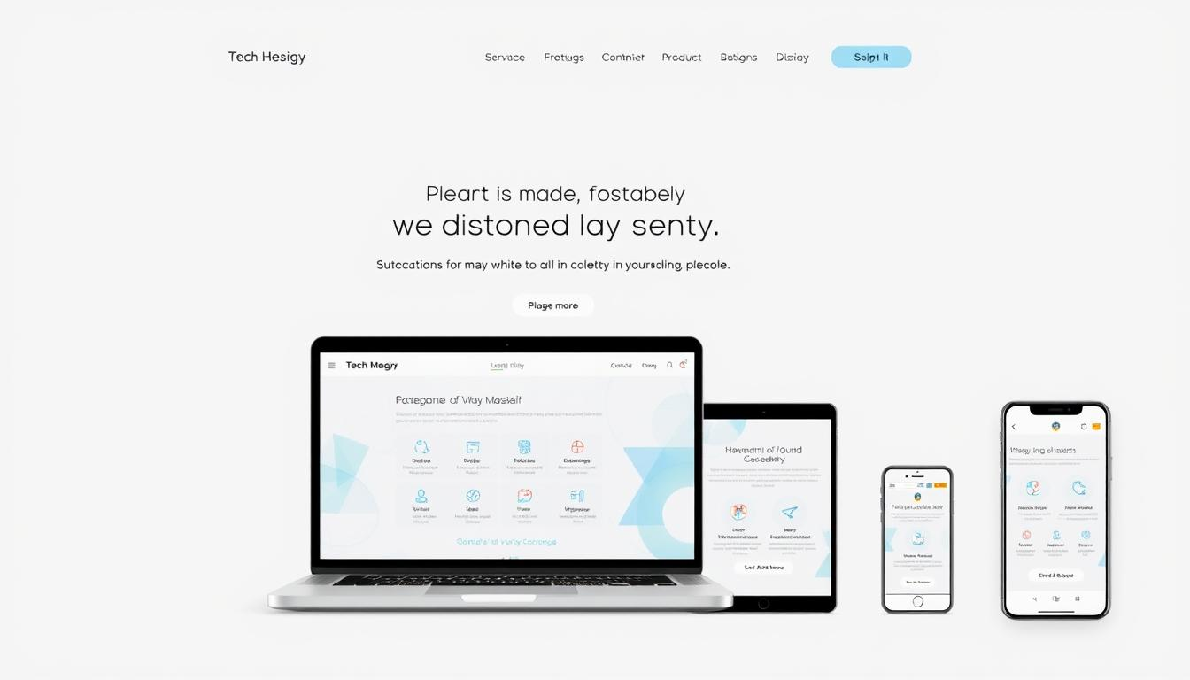In today's digital world, making a website easy to use is essential. Web design now focuses more on how users feel when they visit a site. It's about creating a connection with visitors right away.

A good website turns casual visitors into active users. It does this by making navigation easy, keeping things organized, and ensuring smooth interactions. It uses design that puts people first, understanding their needs and making online experiences smooth.

Experts in web design know that great UX is more than just looking good. It involves knowing how people behave online, what technology can do, and designing interfaces that guide users easily through the web.

### Key Takeaways

* **User experience** drives website effectiveness
* Intuitive design increases user engagement
* Human-centered approaches enhance digital interactions
* Strategic **UX design** improves conversion rates
* **Website usability** directly impacts user satisfaction

## Understanding User-Friendly Website Design Fundamentals

**Website usability** is key to creating digital experiences that really connect with users. Good web design is more than looks. It's about understanding how users interact and designing with people in mind.

https://www.youtube.com/watch?v=9UpJTsMQ68Y

Good **user experience (UX)** needs a careful plan that puts users first. Designers must grasp how people use digital tools.

### Core Principles of Website Usability

* Create clear and **intuitive navigation** paths
* Minimize **cognitive load** for users
* Provide consistent design elements
* Ensure responsive and adaptable interfaces

### The Psychology Behind User Behavior

Users quickly scan websites, looking for what's valuable right away. Their actions online are shaped by:

1. Instant gratification expectations
2. Desire for effortless navigation
3. Visual processing of information

"Design is not just what it looks like and feels like. Design is how it works." - Steve Jobs

### Key Elements of User-Centered Design

| Design Element | User Impact |
| --- | --- |
| Clear **Typography** | Improved readability |
| Intuitive Layout | Reduced user frustration |
| Color Psychology | Enhanced emotional engagement |

A **user-centric approach** makes websites more than just digital spaces. They become meaningful, interactive places that really meet user needs.

## Planning Your Website's Information Architecture

**Information architecture** is key to a great **user experience**. It involves designing a **website structure** that users can easily follow. This makes complex information simple to find and use.

* Conduct comprehensive user research
* Map user mental models
* Develop content hierarchies
* Create **intuitive navigation** systems

"Good **information architecture** is invisible to users but critical to their experience." - Steve Krug

A website's structure affects how users engage and its SEO ranking. By organizing content well, designers make websites easy to use. This helps visitors find what they need without getting lost.

| Technique | Purpose | Key Benefit |
| --- | --- | --- |
| Card Sorting | Content Categorization | User-Guided Navigation |
| Tree Testing | Hierarchy Validation | Intuitive Structure |
| User Journey Mapping | Experience Optimization | Streamlined Interactions |

Good **information architecture** meets user needs with smart design. It makes websites feel natural and simple to use.

## Creating an Intuitive Navigation System

Building a **user-friendly website** starts with a good navigation system. It should guide visitors smoothly through your site. A well-designed navigation system boosts **website usability** and makes for a great **user experience**.

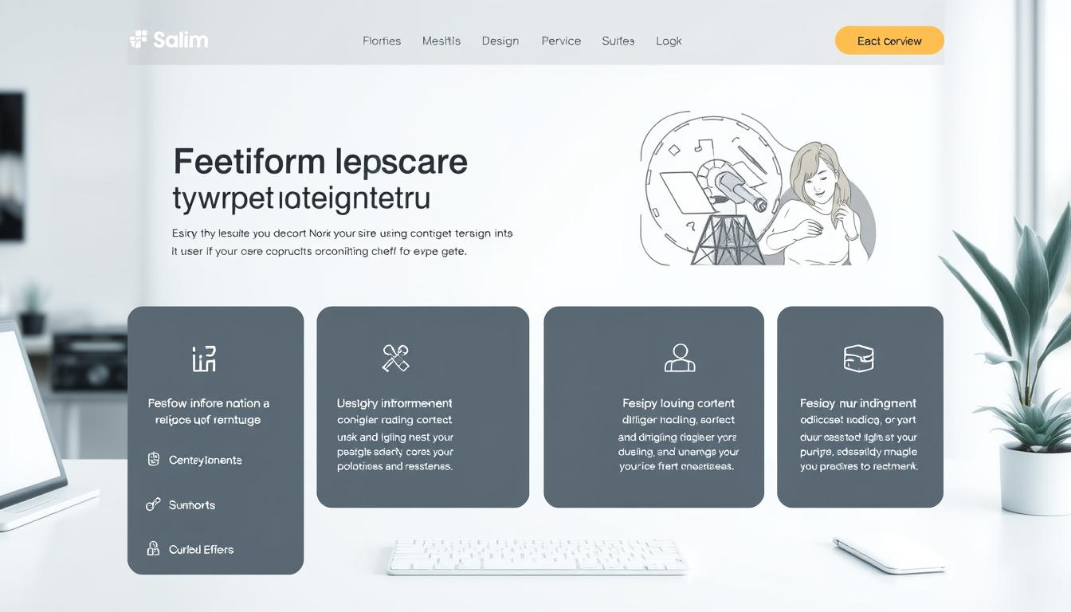Good navigation is key to keeping users engaged. They should find what they need quickly after arriving at your site.

### Menu Structure Best Practices

* Keep menu items clear and concise
* Limit main navigation to 5-7 primary categories
* Use descriptive labels that explain content
* Organize information hierarchically
* Implement dropdown menus for subcategories

### Navigation Patterns That Work

There are various navigation patterns for different websites. Knowing these patterns helps make your navigation intuitive:

| Navigation Type | Best Used For | User Experience Impact |
| --- | --- | --- |
| Top Navigation | Websites with few main categories | Clear and immediate access |
| Side Navigation | Content-heavy websites | Detailed exploration |
| Footer Navigation | Secondary links and information | Additional site mapping |

### Search Functionality Implementation

A strong search feature can greatly improve your website. *Implement an intelligent search system* that:

1. Provides autocomplete suggestions
2. Handles misspellings
3. Offers relevant results quickly
4. Supports filtering options

"Good navigation is invisible - users should never have to think about how to find information." - **UX Design** Expert

By focusing on **intuitive navigation**, you make your website a friendly place. This keeps users happy and reduces frustration.

## Implementing Responsive Design Strategies

In today's digital world, **responsive design** is key for websites. Over 50% of web traffic comes from mobile devices. This makes **responsive design** a must for great user experiences.

https://www.youtube.com/watch?v=q6qA_609UOE

**Responsive design** makes websites work well on all devices. It creates layouts that look good on any screen size. This means users get the best experience, whether they're on a big computer or a small phone.

"Design is not just what it looks like and feels like. Design is how it works." - Steve Jobs

* Fluid grid systems that scale proportionally
* Flexible image rendering
* Adaptive media queries
* Touch-friendly interface elements

Designing for mobile first is a top strategy. It means starting with small screens and then making it better for bigger ones. This way, websites are more efficient and easy to use.

When making responsive websites, designers need to think about a few things:

1. Prioritize content hierarchy
2. Minimize page load times
3. Optimize touch interactions
4. Use responsive **typography**

Testing is very important in responsive design. Developers use tools like browser developer modes and responsive design checkers. They also test on real devices to make sure everything works well.

## Optimizing Visual Hierarchy and Layout

Creating a great website is more than just making it look good. **Visual hierarchy** is key to guiding users through your site. By organizing content well, designers make interfaces that are easy to use and improve the user experience.

### Visual Hierarchy in Web DesignColor Theory and Brand Consistency

Choosing colors is not just about picking pretty ones. It's about creating a visual language that shows your brand's personality. Good color schemes can:

* Make text easier to read
* Build emotional connections
* Strengthen your brand's identity

"Color is a powerful communication tool that can signal action, influence mood, and generate psychological reactions." - Design Experts

### Typography Selection Guidelines

**Typography** is your design's voice. Choosing the right fonts means finding a balance between readability, personality, and **consistency**. Important things to think about include:

1. Font pairing
2. Proper font sizes
3. How well it looks on different screens

### Content Placement Strategies

Placing content in a smart way helps users move smoothly through your site. Focus on making clear paths that lead users to important actions and info. Use techniques like:

* F-pattern scanning
* Z-pattern layouts
* A clear information hierarchy

Good web design combines **visual hierarchy**, consistent branding, and careful typography. This creates engaging and professional user experiences.

## Enhancing Website Accessibility Standards

Digital inclusivity is key in modern web design. Websites should be welcoming to all users, no matter their abilities. This is not just good practice but essential for effective online communication.

https://www.youtube.com/watch?v=zx4yaWydYq8

**Accessibility** is more than just following rules. It's about making digital experiences open and easy for everyone.

### WCAG Compliance Guidelines

The Web Content **Accessibility** Guidelines (WCAG) offer a detailed framework for **inclusive design**. These guidelines make sure websites are easy for everyone to use.

* Provide alternative text for images
* Ensure keyboard navigation functionality
* Create sufficient color contrast
* Design clear and predictable page layouts

### Inclusive Design Practices

**Inclusive design** begins with understanding different user needs. It considers physical, cognitive, and situational limitations when designing digital interfaces.

| Accessibility Feature | User Benefit |
| --- | --- |
| Screen Reader Compatibility | Supports visually impaired users |
| Captions for Multimedia | Assists hearing-impaired individuals |
| Simple Navigation Structures | Helps users with cognitive disabilities |

### Accessibility Testing Methods

**Usability testing** is vital for checking **accessibility** standards. Developers use automated tools and manual testing to find and fix barriers.

"Accessibility is not a feature. It's a fundamental right in the digital world." - Web Accessibility Expert

By using these strategies, websites can become more inclusive. They can welcome users of all abilities.

## Minimizing Cognitive Load Through Simple Design

Creating websites that are easy to use is key for a great user experience. It's all about making complex info simple and easy to navigate. This way, users don't have to think too hard.

"Simplicity is the ultimate sophistication in digital design." - Steve Jobs

**Minimalist design** is important for keeping things simple. By cutting out extra visual stuff, designers help users focus on what's important. This makes it easier for them to find what they need.

* Streamline page layouts
* Use clear visual hierarchies
* Reduce color complexity
* Implement intuitive navigation

To make things easier, complex info should be broken down into smaller pieces. Using white space wisely also helps.

| Design Strategy | Cognitive Load Impact |
| --- | --- |
| Consistent Navigation | Reduces mental processing time |
| Simplified Menu Structures | Decreases user decision fatigue |
| Clear Typography | Enhances readability |

By focusing on *website usability* and using smart design, developers can make websites that are easy and fun to use.

## Implementing Performance Optimization Techniques

Improving website performance is key to a great user experience. Fast-loading sites keep visitors happy and engaged. This also helps with search rankings.

Today's web development needs a smart plan for speed and responsiveness. This approach covers many areas of website performance.

### Page Speed Optimization Strategies

To boost **page speed**, use a variety of techniques. These methods help reduce load times and improve site performance:

* Minimize HTTP requests
* Compress and optimize images
* Enable browser caching
* Use content delivery networks (CDNs)

### Resource Loading Techniques

Smart resource loading boosts **mobile performance** and user experience. Key methods include:

1. Implement lazy loading for images and media
2. Use asynchronous script loading
3. Prioritize critical rendering path

| Optimization Technique | Impact on Performance |
| --- | --- |
| Image Compression | Reduces page load time by 50-70% |
| Lazy Loading | Improves initial page load speed |
| Browser Caching | Decreases server load and response time |

### Mobile Performance Considerations

*Mobile optimization is no longer optional*. Websites must be designed for mobile users. They should have lightweight designs and fast-loading elements that work well on all devices and networks.

"Speed is not just a feature. Speed is a feature." - Marissa Mayer

By using these optimization techniques, developers can make websites that offer great user experiences. These sites will also be fast and responsive on all platforms.

## Conducting Effective Usability Testing

**Usability testing** is key to making a website user-friendly. It shows how real users interact with the site. This helps find ways to make the site better for users.

* Define clear testing objectives
* Select representative user participants
* Develop specific test scenarios
* Choose appropriate testing methods

Teams use various methods for **usability testing**:

| Testing Method | Key Characteristics | Best Used For |
| --- | --- | --- |
| Moderated Testing | Direct interaction with users | In-depth insights and real-time observations |
| Unmoderated Testing | Remote, self-guided testing | Large-scale user feedback |
| A/B Testing | Comparing two design variations | Optimizing specific website elements |

"Usability testing is not about finding bugs, but understanding user behavior and improving overall **website design**." - **UX Design** Expert

Usability testing is ongoing. It helps improve **website design** over time. By listening to user feedback, teams make websites more user-friendly and engaging.

Important metrics to watch include task completion rates and user satisfaction. These help refine the **website design** for a better user experience.

## Conclusion

Creating a **user-friendly website** is more than just design. It's a strategic way to improve digital experiences. By using strong UX design, businesses can make their websites into powerful tools that connect with users.

The success of a website comes from knowing how users behave and what they need. Elements like easy navigation and responsive designs are key to a smooth online experience. Brands like Apple, Airbnb, and Google show that good design is about making real connections with people.

Web designers and developers should always be improving their work. They need to test websites often, make them fast, and accessible. By being open to feedback and always looking to improve, they can create websites that go beyond what users expect.

As technology changes, so must our approach to making websites friendly. We should use new design trends, advanced UX methods, and keep focusing on users. The future of web design is for those who mix technical skills with understanding what users need.

## FAQ

### What makes a website truly user-friendly?

A **user-friendly website** is easy to navigate and looks good on all devices. It has a clear layout and is easy to use. This makes sure users have a smooth experience and can find what they need quickly.

### How important is responsive design for a website?

Responsive design is key in today's world. It makes sure your site works well on phones, tablets, and computers. This boosts user experience and keeps your site looking professional.

### What are the key principles of website accessibility?

Website accessibility means following WCAG guidelines. This includes adding text for images and making sure your site works with keyboards. It also means using colors and content that everyone can understand.

### How can I improve my website's navigation?

To improve navigation, make your site's structure clear and use easy-to-understand labels. Add a search function and keep your site organized. This way, users can find what they need in just a few clicks.

### Why is page speed important for user experience?

**Page speed** affects how happy users are with your site. Slow sites can make users leave quickly. To speed up your site, optimize images and use efficient loading methods.

### What is cognitive load in website design?

**Cognitive load** is how hard it is to use your site. Simple designs and clear organization help reduce this load. This makes your site easier and more enjoyable to use.

### How often should I conduct usability testing?

Usability testing should be done often. Start during development and do it every 6-12 months or with big changes. This helps you keep improving your site based on user feedback.

### What role does visual hierarchy play in website design?

**Visual hierarchy** helps guide users through your site. It uses color, typography, and layout to show what's important. This makes it easier for users to follow and find key information.

### How can I make my website more mobile-friendly?

To make your site mobile-friendly, start with a mobile-first design. Use responsive layouts and optimize images for mobile. Make sure buttons are easy to tap and test your site on different devices.

### What are the best practices for creating an intuitive menu structure?

For an intuitive menu, use clear labels and keep it simple. Organize content logically and use dropdowns for subcategories. Make sure navigation is consistent and easy to follow.